**CSE102L Computer Programming Lab**

**LAB # 7**



**2020**

**Submitted to:**

**Engr. Abdullah Hamid**

**Submitted by:**

**TAYYABA**

**Registration No :**

**19PWCSE1854**

**Semester: 2nd**

**Class Section:** **C**

“On my honor, as student of University of Engineering and Technology,

I have neither given nor received unauthorized assistance on this

academic work.”

July 16 , 2020

**Department of Computer Systems Engineering**

**University of Engineering and Technology, Peshawar**

**Task 1:**

**Title:**

Print 1 to 100 using recursive function in C++.

**Code**:

#include<iostream>

using namespace std;

void x();

int main()

{

x();

return 0;

}

void x()

{

static int i = 1;

if(i > 100) return;

cout<<i<<"\t";

i++;

x();

}

**Output**:

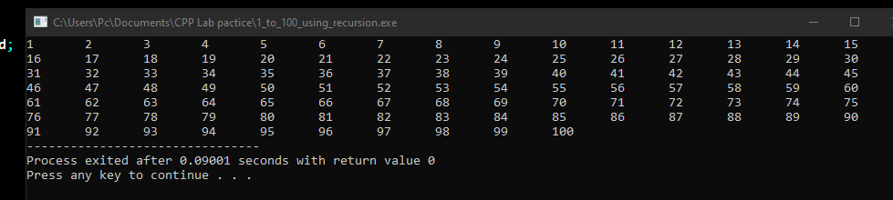

**Task** **2:**

**Title**:

Write a C++ program where you take two values from user if the user enter one or two of the values zero instead of passing the zero values to the function let the function calculate default values if user enters values other than zero pass them to function and calculate their sum.

**Code**:

#include<iostream>

using namespace std;

int sum(int x = 5, int y = 25);

int main()

{

int i, j;

cout<<"Enter First num: ";

cin>>i;

cout<<"Enter second num: ";

cin>>j;

if((i==0)&&(j==0))

{

cout<<sum();

}else if((i==0) || (j==0))

{

cout<<((i==0)?sum(j):sum(i));

}else

{ cout<<sum(i,j);

}

return 0;

}

int sum(int x, int y)

{ return x + y; }

**Output**:

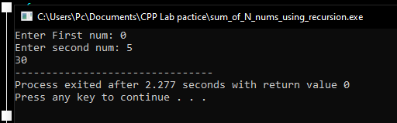

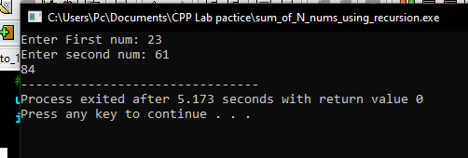

**Task 3:**

**Title**:

Write a function to find Sum of N natural numbers using Recursion.

**Code**:

#include<iostream>

using namespace std;

int sum(int x);

int y;

int main() {

cout<<"Enter a number: ";

cin>>y;

cout<<"Sum from 1 to "<<y<<" is "<<sum(y);

return 0;

}

int sum(int x)

{

for(int i = 0; i<y; i++)

x= x+i;

return x;

}

**Output**:

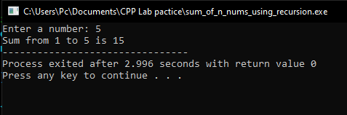

**Task 4:**

**Title**:

Calculate the sum of odd natural numbers 1+3+5+7+……………. + n using Recursion. Take n as input from user.

**Code**:

#include<iostream>

using namespace std;

int sum(int x);

int y;

int main() {

cout<<"Enter a number: ";

cin>>y;

cout<<"Sum from 1 to "<<y<<" is "<<sum(y);

return 0;

}

int sum(int x)

{

for(x = 0; x<y; x++)

x = x+(x+2);

return x;

}

**Output**:

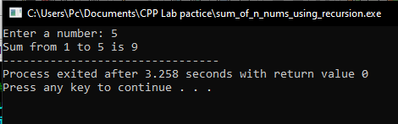

**Task 5:**

**Title**:

Overload three functions with name grade() one function should accept marks(int) and output the percentage and the other function should accept the percentage(float) and display the grade based on the percentage from previous function finally the third function also named grade should make a call to these other two functions.

**Explanation**:

**Code**:

#include<iostream>

using namespace std;

int x;

void grade();

float grade(int marks);

void grade(float percentage);

int main()

{

cout<<"Enter your marks (Total = 500): ";

cin>>x;

grade();

return 0;

}

float grade(int marks)

{ return (((float) (marks))/500)*100;

}

void grade(float percentage)

{

cout<<"Your grade is ";

if(percentage > 90)

{ cout<<"A+";

}else if(percentage > 80)

{

cout<<"A";

}else if(percentage > 70)

{ cout<<"B+";

}else if(percentage > 60)

{ cout<<"B";

}else if(percentage > 50)

{

cout<<"C+";

}else if(percentage > 40)

{

cout<<"C";

}else if(percentage > 30)

{

cout<<"D";

}else { cout<<"F";

}

}

void grade() {

float per = grade(x);

cout<<"Your percentage is "<<per<<endl;

grade(per);

}

**Output**:

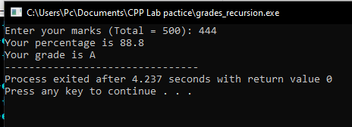

**Task 6:**

**Title:**

Write a C++ Program to Find Factorial of a Number Using Recursion.

**Code**:

#include<iostream>

using namespace std;

int fact(int n);

int main() {

int x;

cout<<"Enter a number for factorial: ";

cin>>x;

if(x >= 0) cout<<"Factorial of "<<x<<" is "<<fact(m);

else

cout<<"Factorial of negative numbers cannot be calculated.";

return 0;

} int fact(int n)

{

if(n == 0) return 1;

return n * fact(n - 1);

}

**Output**:

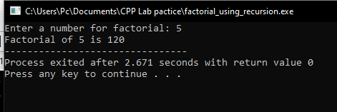

**Task #7:**

**Title:**

C++ Program to Find L.C.M Using Recursion.

**Code:**

#include<iostream>

using namespace std;

int lcm(int x, int y);

int main()

{

int i, j;

cout<<"Enter first number: ";

cin>>i;

cout<<"Enter second number: ";

cin>>j;

cout<<"LCM of "<<i<<" and "<<j<<" is "<<lcm(i,j);

return 0;

}

int lcm(int x, int y)

{

static int xiv = x;

if(x % y == 0) return x;

x += xiv;

return lcm(x, y);

}

Output:

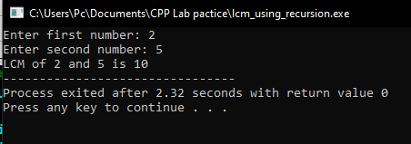

**Task #8:**

**Title:**

C++ program to print Fibonacci series using recursion.

**Code:**

#include<iostream>

using namespace std;

void fib(int n);

int main()

{

int x;

cout<<"Enter a number to find fibonacii seriese upto that number: ";

cin>>x;

fib(x);

return 0;

} void fib(int n)

{

static int i = 0, j = 1;

cout<<i<<", ";

j+= i;

i = j - i;

if(i > n) return;

fib(n);

}

**Output:**

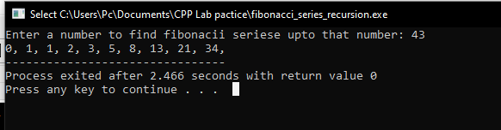

**Task #9:**

**Title:**

C++ program to calculate power of a number using recursion.

**Code:**

#include<iostream>

using namespace std;

int power(int base, int exp);

int main()

{

int num, exp;

cout<<"Enter number: ";

cin>>num;

cout<<"Enter exponent: ";

cin>>exp;

cout<<num<<" Raised to power "<<exp<<" is "<<power(num, exp);

return 0;

}

int power(int base, int exp)

{ int static x = base;

if(exp == 1)

return base;

base = base * x;

return power(base, --exp);

}

**Output:**

